**Assignment 5**

Based on the readings, lecture slides, and materials in the Module 4, answer the below questions and submit via blackboard in a .docx or .pdf format.

To perform this assignment, you will need to use the Valentina Studio that we have been using this semester to create your own database. This will give students the foundational and practical knowledge of how to create their own databases for future data storage, retrieval, and manipulation efforts.

Within this database, you will be creating two tables and need to pick the appropriate data storage types for each column in the tables. Use assignment readings and slides to support building each of the following tables

**Creating the database:**

1. In Valentina Studio, on the Start Page Tab, click the “New Database” button. This is often located on the bottom center of the screen, and looks like this: 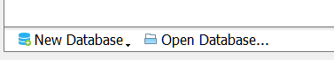
2. Next, Select Valentina Files if prompted to choose.
3. Following this, you’ll be prompted to name the file. Name the file your first initial, and last name. For me this is jklemm, and looks like what is below, then click “Create”:

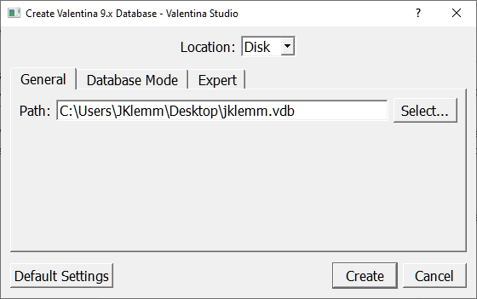

1. Here, you will be brought to the schema editor. Which looks like the screenshot below. Select your new database by clicking on it, and then click the SQL button to open up a query editor:

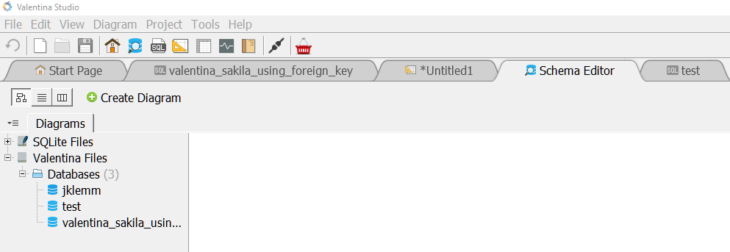

**My new database as below;**

**Guided Table Build: We will be Creating a Table called Student For the 6 following questions, your submission will be the query that shows you’ve created the table conforming to the requirements.**

1. Create a Table Named Student.
2. The first column should be named ID, and have a data type of Integer
3. The second column should be named First_Name, and have a data type of varchar(255).
4. The third column should be named Last_Name, and have a data type of varchar(255)
5. The fourth column should be named DOB (short for date of birth), and have a data type of date.
6. The firth column should be named Adv_ID (short for advisor ID), and have a data type of integer.

**Answer**

**CREATE TABLE Student (**

**ID INT,**

**First_Name varchar(255),**

**Last_Name varchar(255),**

**DOB DATE,**

**Adv_ID INT**

**);**

**Query Results: For the 4 following questions, your submission will be the query that shows you’ve created the table conforming to the requirements.**

1. Create a Table Named Advisor
2. Include an ID column
3. Include a First_Name column
4. Include a Last_Name column

**Answer**

**CREATE TABLE Advisor (**

**ID INT,**

**First_Name varchar(255),**

**Last_Name varchar(255)**

**);**

